# Combo-Attack! Combining Multiple Data Manipulations

This document includes the question, the solution, and a breakdown of the code provided in the screenshot.

## Uploaded Screenshot

Below is the screenshot of the task:

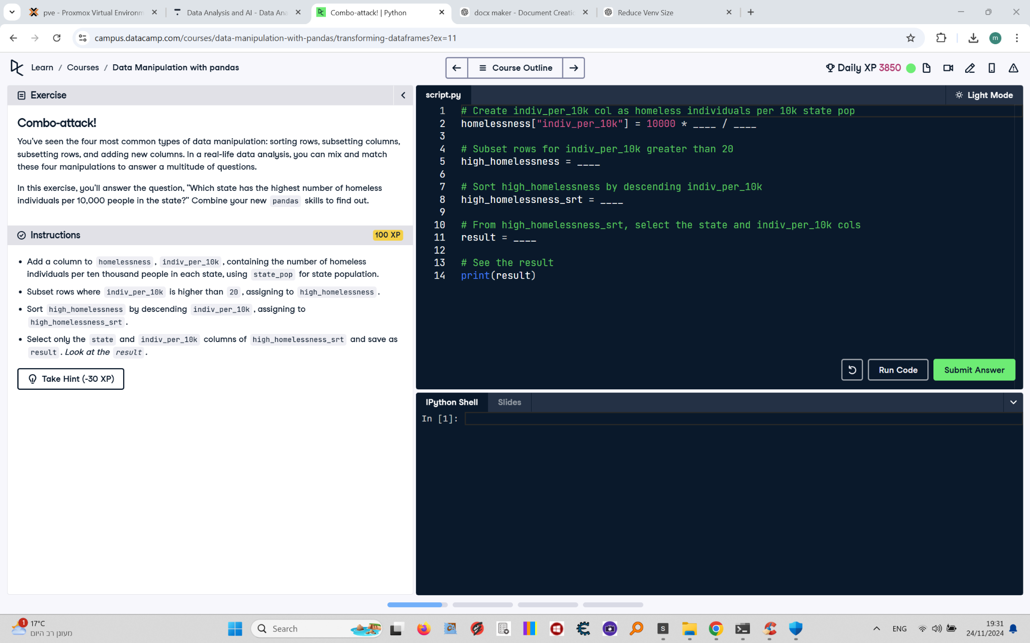

## Question

1. Add a column to `homelessness`, `indiv_per_10k`, containing the number of homeless individuals per 10,000 people in each state, using `state_pop` for state population.  
2. Subset rows where `indiv_per_10k` is higher than 20, assigning to `high_homelessness`.  
3. Sort `high_homelessness` by descending `indiv_per_10k`, assigning to `high_homelessness_srt`.  
4. Select only the `state` and `indiv_per_10k` columns of `high_homelessness_srt` and save as `result`. View the `result`.

## Answer

# Create indiv_per_10k col as homeless individuals per 10k state pop  
homelessness['indiv_per_10k'] = 10000 * homelessness['individuals'] / homelessness['state_pop']  
  
# Subset rows for indiv_per_10k greater than 20  
high_homelessness = homelessness[homelessness['indiv_per_10k'] > 20]  
  
# Sort high_homelessness by descending indiv_per_10k  
high_homelessness_srt = high_homelessness.sort_values('indiv_per_10k', ascending=False)  
  
# From high_homelessness_srt, select the state and indiv_per_10k cols  
result = high_homelessness_srt[['state', 'indiv_per_10k']]  
  
# See the result  
print(result)

## Code Explanation

# Explanation of the code:

1. `homelessness['indiv_per_10k'] = 10000 * homelessness['individuals'] / homelessness['state_pop']`: Adds a new column `indiv_per_10k` to the `homelessness` DataFrame, calculating the number of homeless individuals per 10,000 people in each state.

2. `homelessness[homelessness['indiv_per_10k'] > 20]`: Subsets the rows where `indiv_per_10k` is greater than 20 and assigns the result to `high_homelessness`.

3. `high_homelessness.sort_values('indiv_per_10k', ascending=False)`: Sorts the `high_homelessness` DataFrame in descending order based on the `indiv_per_10k` column and assigns it to `high_homelessness_srt`.

4. `high_homelessness_srt[['state', 'indiv_per_10k']]`: Selects the `state` and `indiv_per_10k` columns from the `high_homelessness_srt` DataFrame and assigns the result to `result`.

5. `print(result)`: Prints the resulting DataFrame to verify the calculations and filtering.